Requirements that need to be Fixed:

All links in the installation manual have "<http://localhost:8080/>" as the IP address, but the site redirects to "<http://localhost:8443/>" when run.

Login button just takes you to a “site can’t be reached page”, probably because it takes you back to the local 8080 IP.

Could convert to environment variables for sensitive data in application.properties

-Change the storing of passwords into public repository

SQL data is not being inserted into our MySQL tables; There are no listings, categories, or credit card types being populated in the site.

Sign up display interface should be aligned vertically not horizontally.

Security Question answers are stored in plain text in the database.

Future Updates and Fixes:

The issue with the incorrect port number can be resolved by changing the “server.port” value to the default of 8080 in the “application.properties” file.

Move plain text sensitive information to environment variables stored on the host computer.

The SQL error could be a result of incorrect setup of MySQL workbench, or it isn’t being called properly in the code. Will have to determine the cause and correct it.

Encrypt the answers to the Security Questions before putting them into the database.

SSL:

* Program needs to run on SSL on an external Tomcat server
* <https://excalibur.sru.edu:8443/OnlineAuction/>

Logins:

* Logins need to be crated correctly
* The logic for creating an initial admin account is in SignUpController.java starting on line 304 (see below). You have to create account with a user name like “adminwidget” for admin or “adminsuper” for super admin. These accounts do not need an initial email verification, but 2fa can be enabled. It’s probably worth mentioning that this is a very poor practice that we left in for creating our admin accounts.

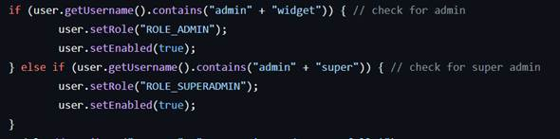

* Initial logins need to be loaded in using an SQL file

Discussion Boards

* Discussion boards for users to discuss about items

